|  |
| --- |
| Tafe Final Project |
| Grande Gift Hamper Australia |
| Using ASP.Net Core 2.0 Code First, Entity Framework and Identity  Project Deployed on Microsoft Azure |
| Source Code Control on Microsoft Devops |

|  |
| --- |
| Alex Huk Kok Lung  6-14-2019 |

Contents

**Home Page** 3

Images in Slide Show 3

**As an Unregistered User, I Can…** 5

1. View Home Page 5

2. View About Page (With Dummy Data) 5

3. View Contact Page (With Dummy Data) 6

4. View Privacy Page (With Dummy Data) 6

**As an Unregistered User, I Cannot…** 6

1. View Hamper 6

**As a User, I Can…** 7

1. Register an Account 7

User Data Validation 8

**As a Registered User, I Can …** 9

1. See My User Name, Shopping Cart and Shopping History 9

2. View Items in Hamper 9

3. Search Hamper by Category 10

4. Filter Hampers by Min Price and Max Price 10

5. View Hamper 11

6. Leave Feed Back 11

7. Order Hamper (Session Time Out: 1 hour) 12

8. Check out (Can Choose Your Prefer Address) 12

9. Place Order and View History 13

10. Change Profile 13

11. Add New, Edit or Delete Address 13

12. Change Password 14

**As an Admin, I Can…** 14

1. Create New Hamper 15

2. Edit Hamper 15

3. Soft Delete Hamper 16

3.1. After Delete, Find it in Old Hamper 16

3.2. Restore Hamper, Select No 16

4. View Category 17

4.1. Create New Category 17

4.2. Edit Category 17

4.3. Delete Category 18

**Web Api** 18

1. Get All Data 18

2. Get Data by Category 19

**Source Code Control on Microsoft Devops** 20

1. Version Control 20

2. User Story Board 20

3. Work Flow Chart 21

**Deploy on Microsoft Azure** 21

Web App URL 22

Database 22

Web Page 23

**To Find Out More…** 23

# **Home Page**

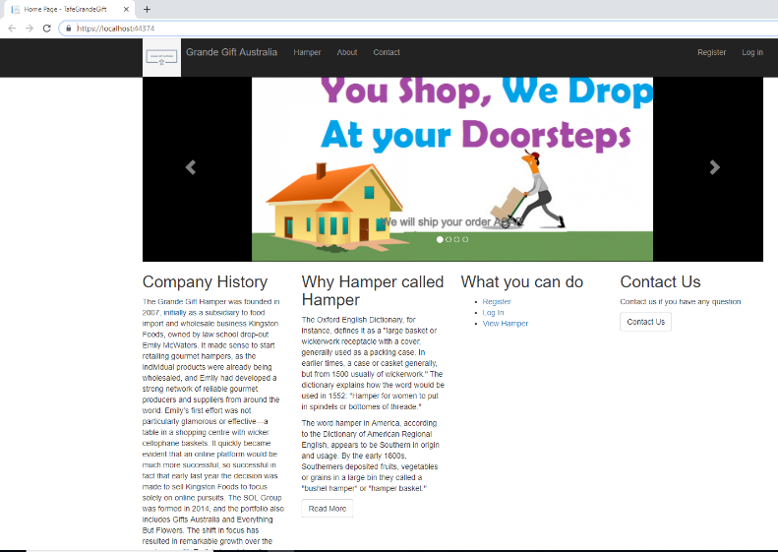

## Images in Slide Show

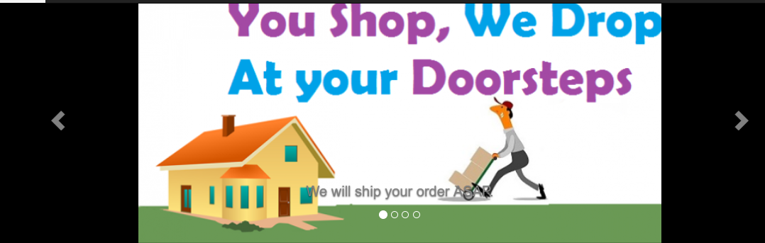

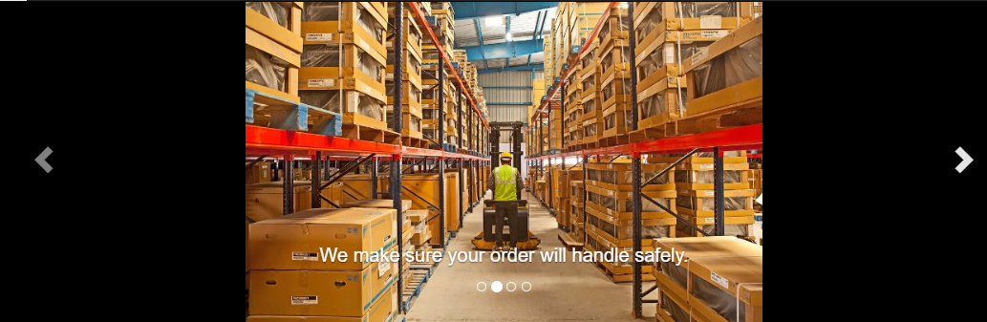

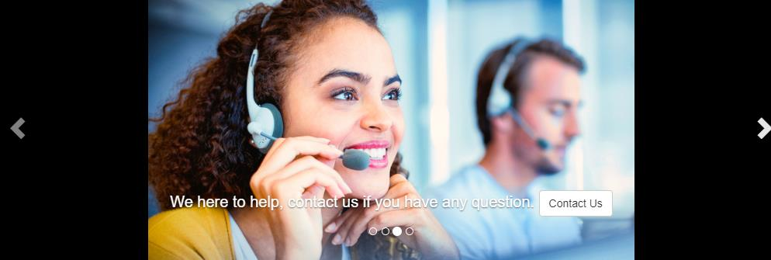

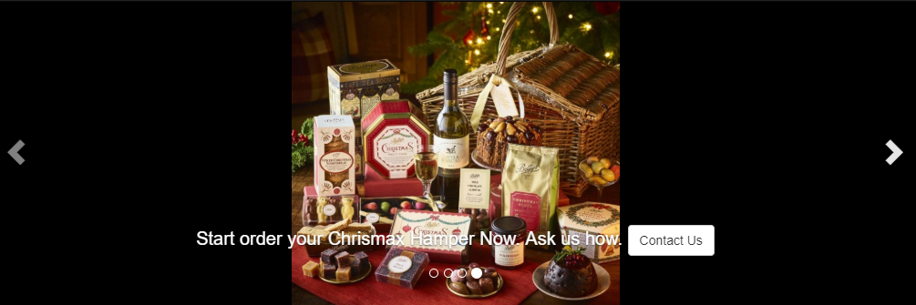

# **As an Unregistered User, I Can…**

## View Home Page

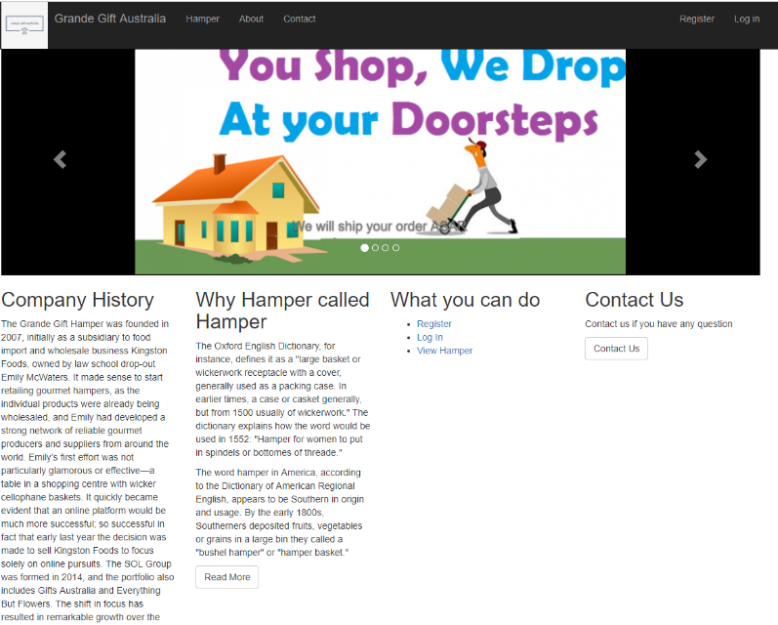

## View About Page (With Dummy Data)

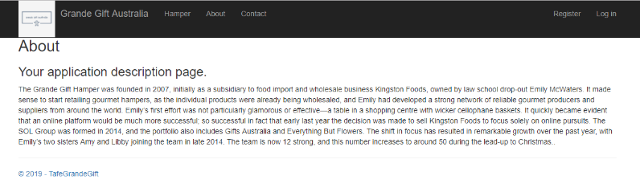

## View Contact Page (With Dummy Data)

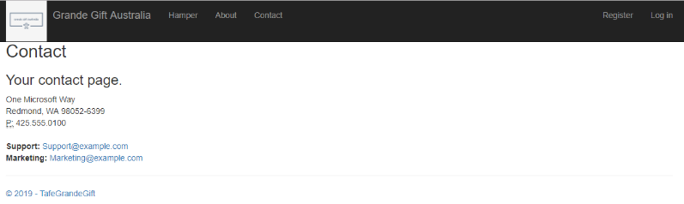

## View Privacy Page (With Dummy Data)

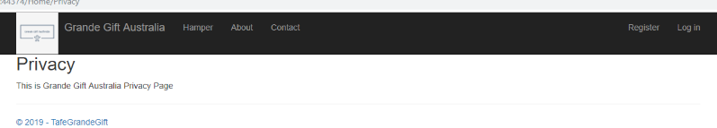

# **As an Unregistered User, I Cannot…**

## View Hamper

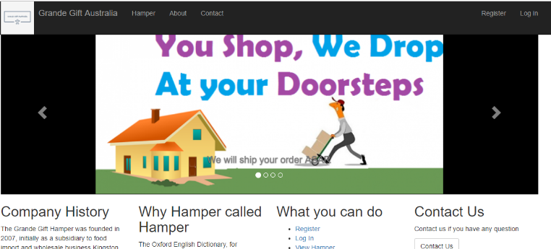

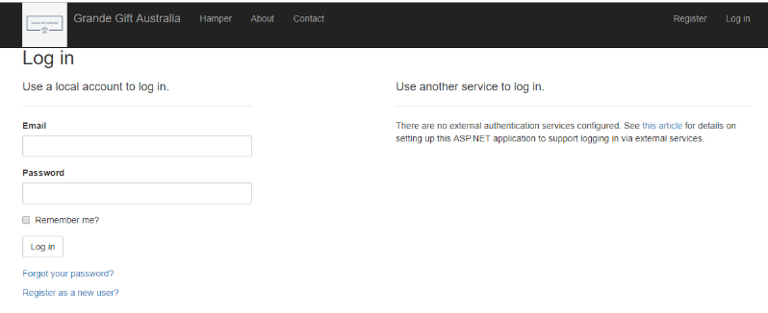

# **As a User, I Can…**

## Register an Account

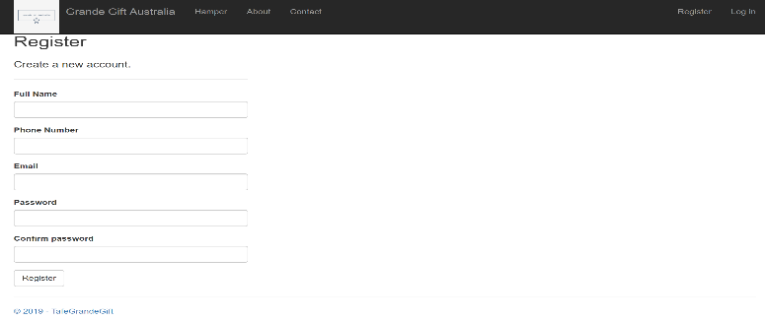

## User Data Validation

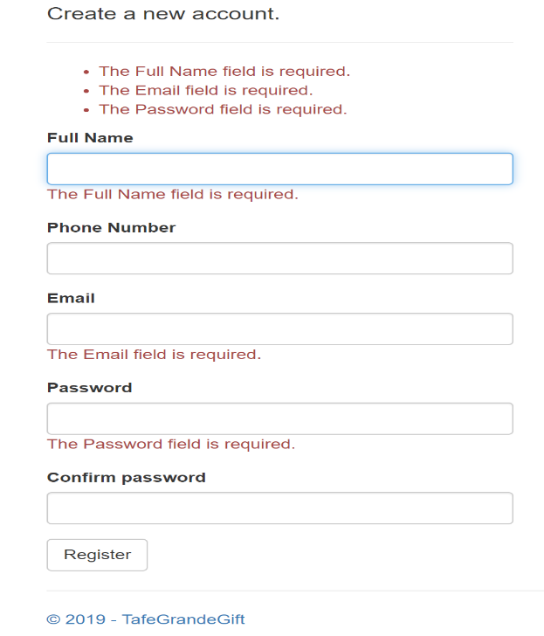

# **As a Registered User, I Can …**

## See My User Name, Shopping Cart and Shopping History

Registered User (Log in with Dummy Account)



Unregistered User



## View Items in Hamper

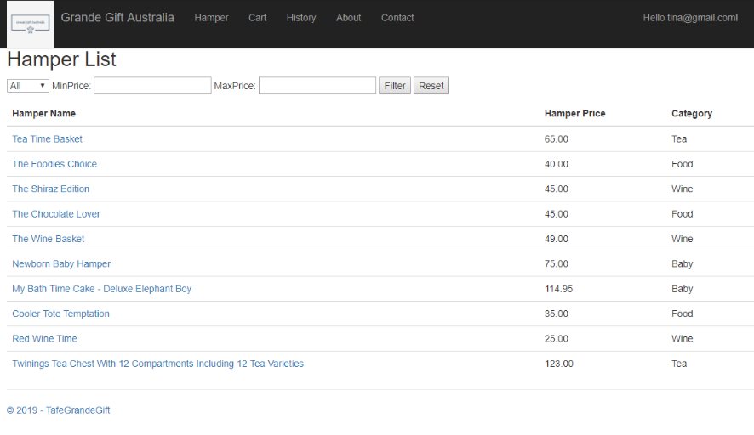

## Search Hamper by Category

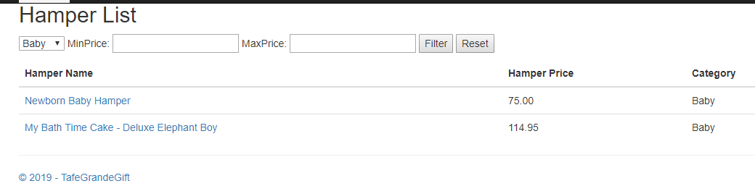

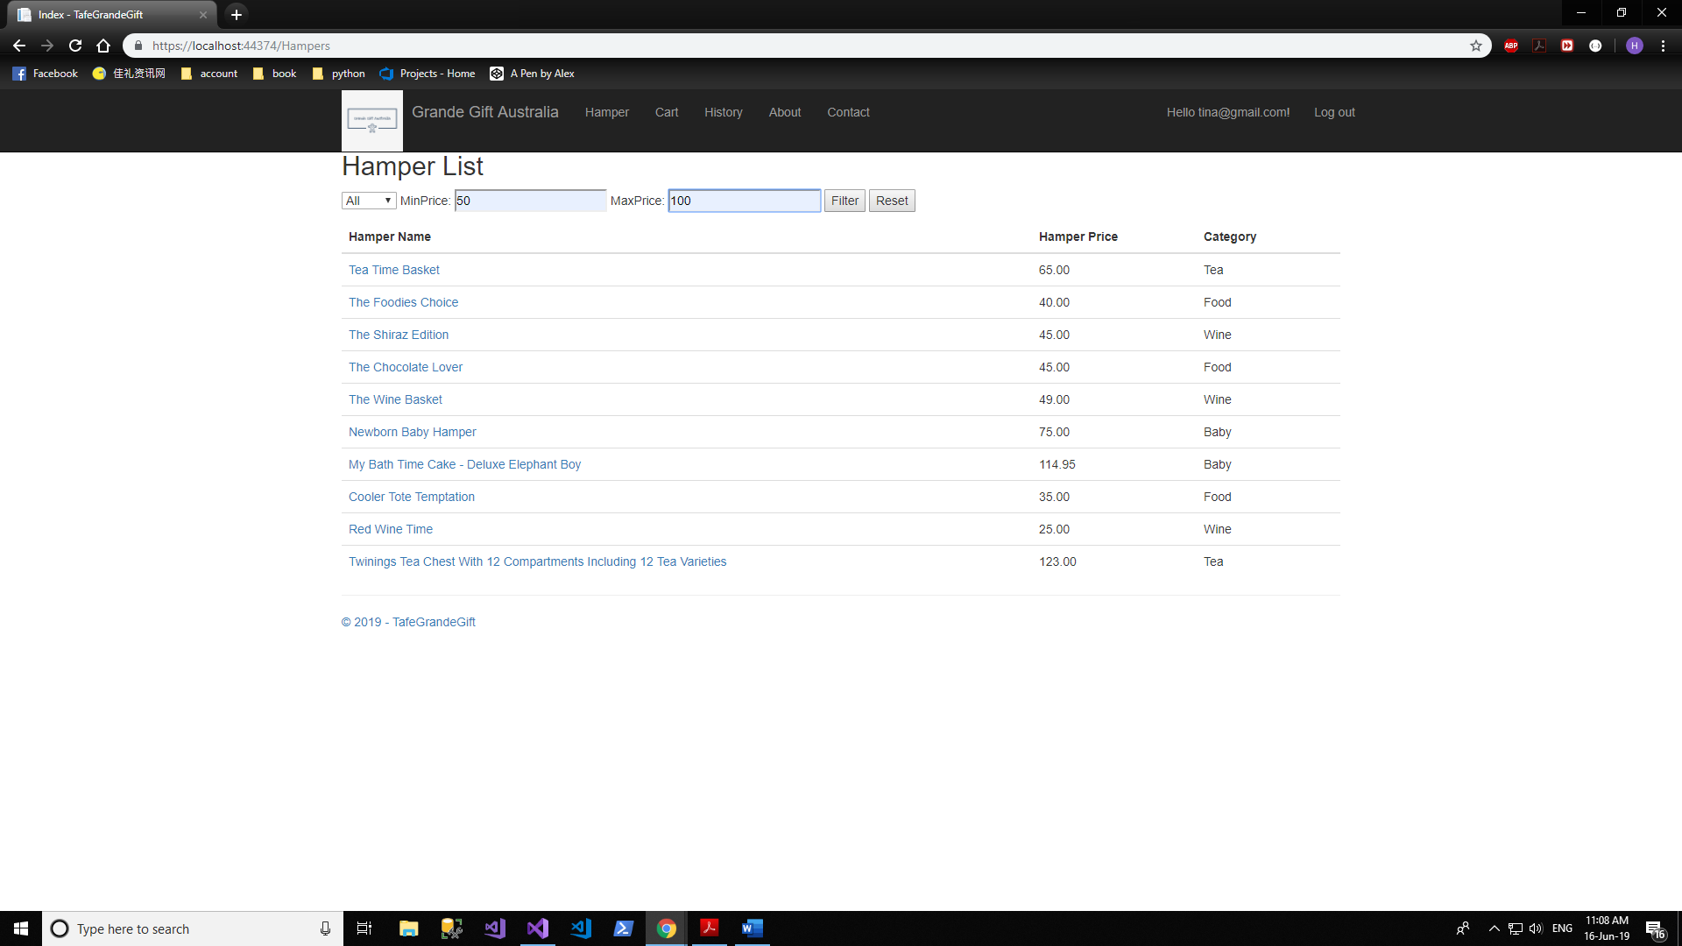

## Filter Hampers by Min Price and Max Price

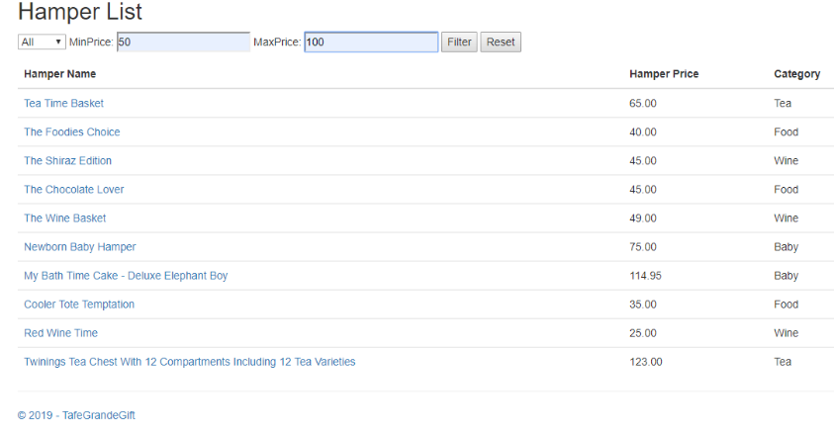

Result

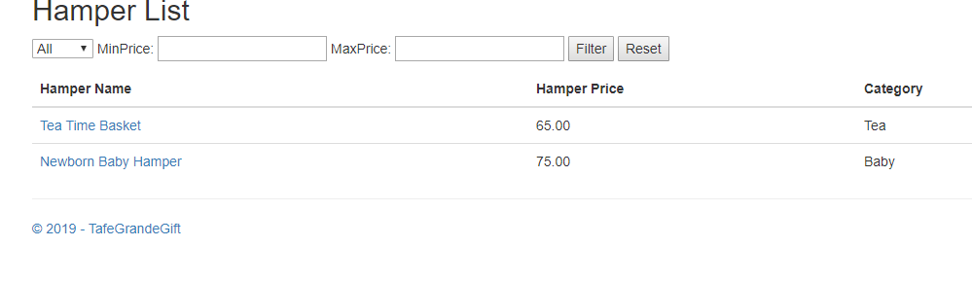

## View Hamper

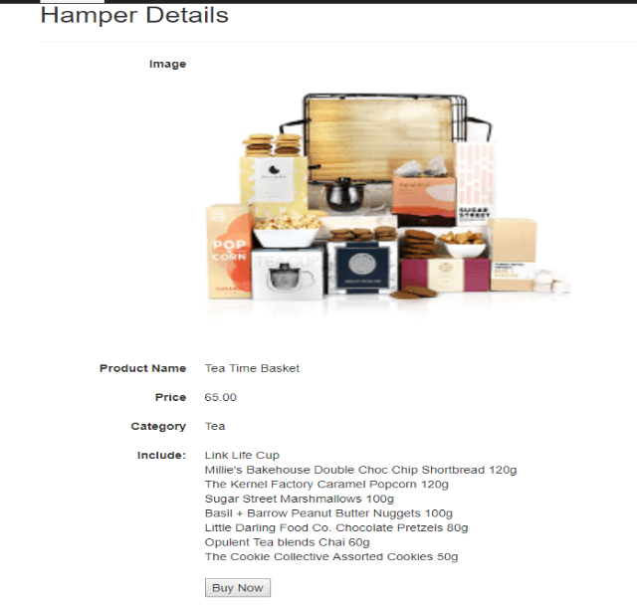

## Leave Feed Back

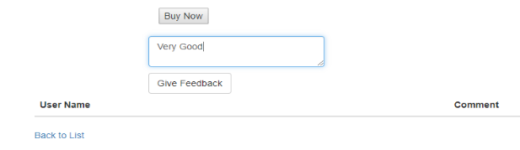

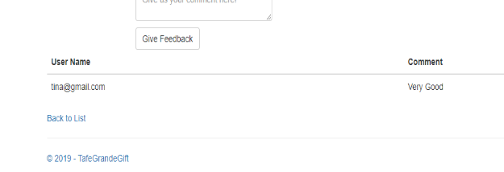

## Order Hamper (Session Time Out: 1 hour)

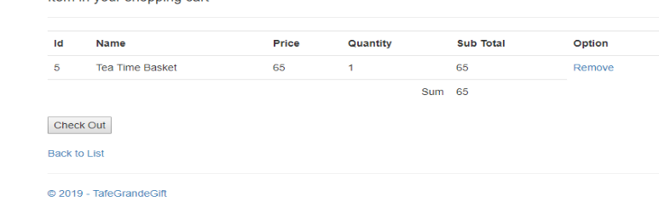

## Check out (Can Choose Your Prefer Address)

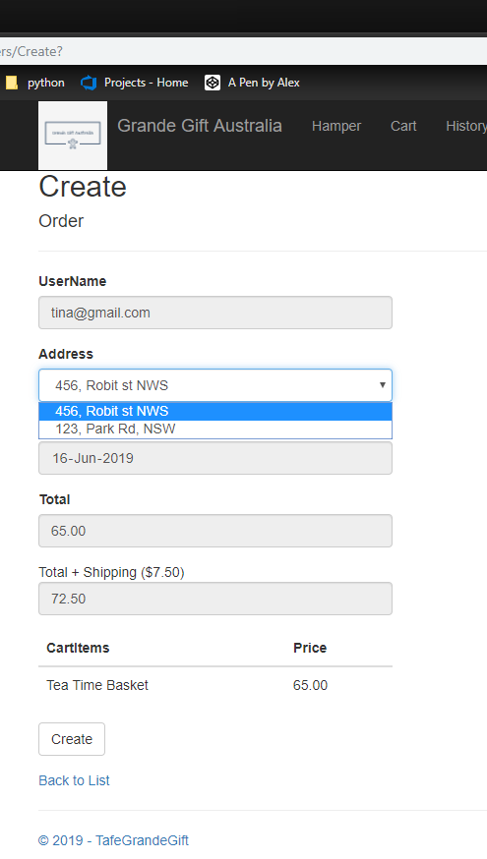

## Place Order and View History

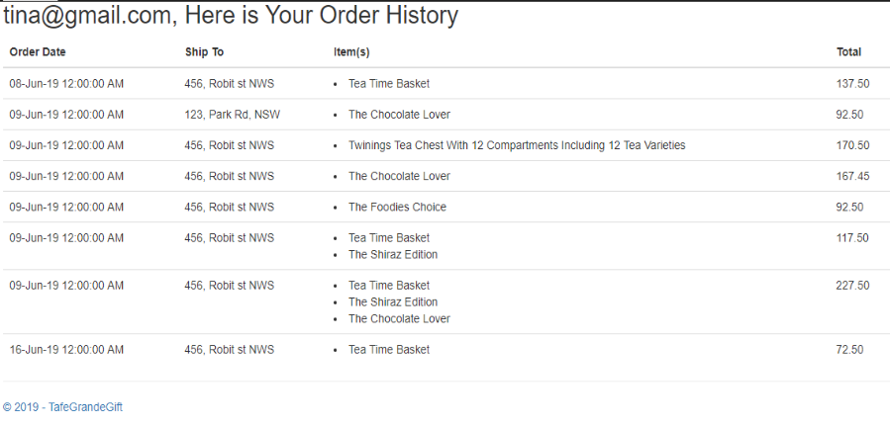

## Change Profile

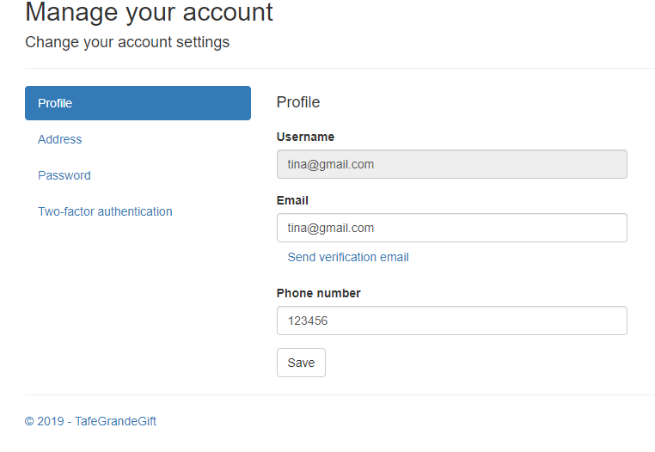

## Add New, Edit or Delete Address

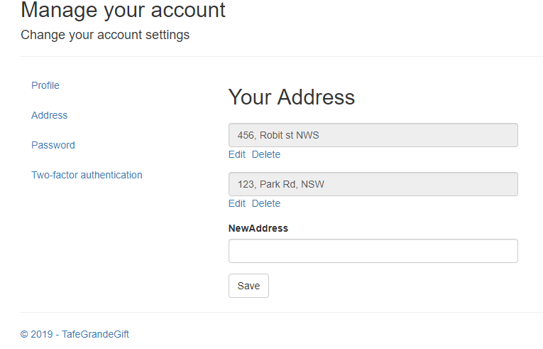

## Change Password

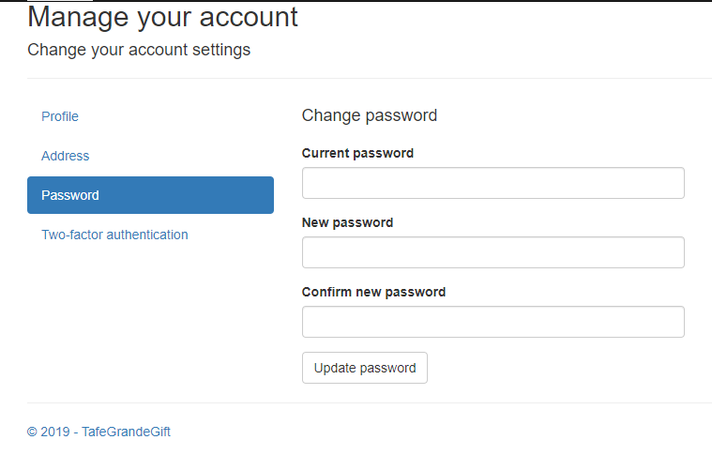

# **As an Admin, I Can…**

Admin



Registered User (Log in with Dummy Account)



Unregistered User



## Create New Hamper

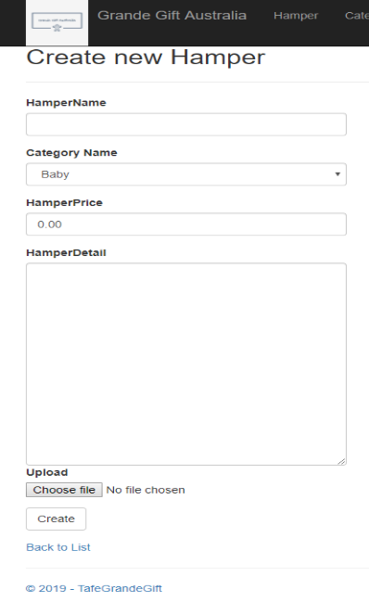

## Edit Hamper

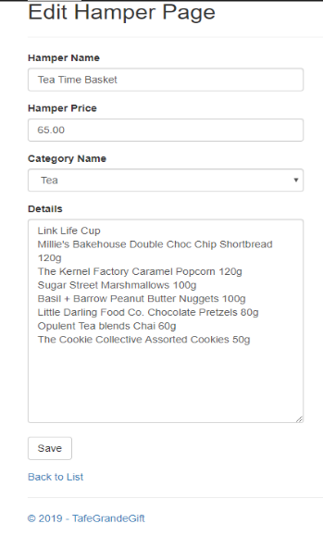

## Soft Delete Hamper

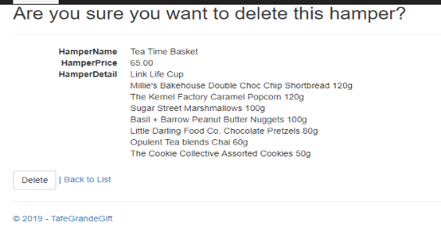

### After Delete, Find it in Old Hamper

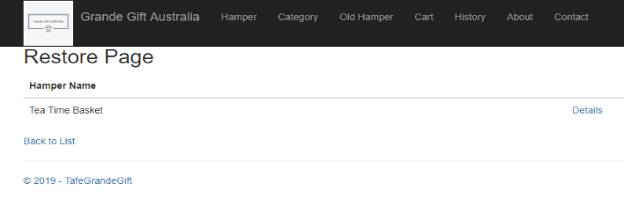

### Restore Hamper, Select No

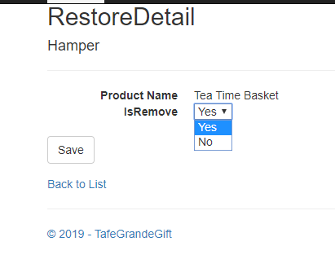

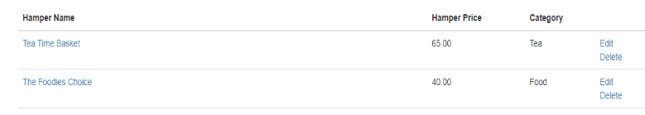

## View Category

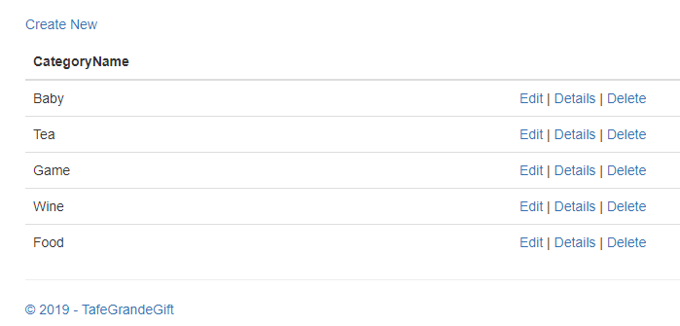

### Create New Category

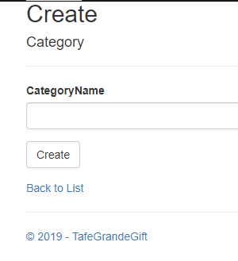

### Edit Category

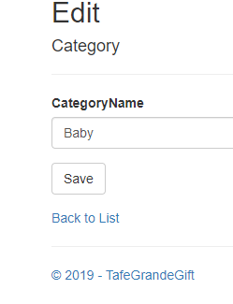

### Delete Category

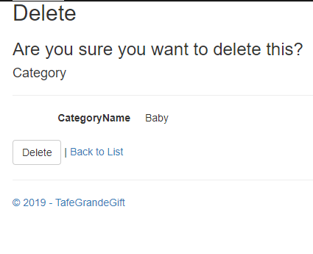

# **Web Api**

## Get All Data

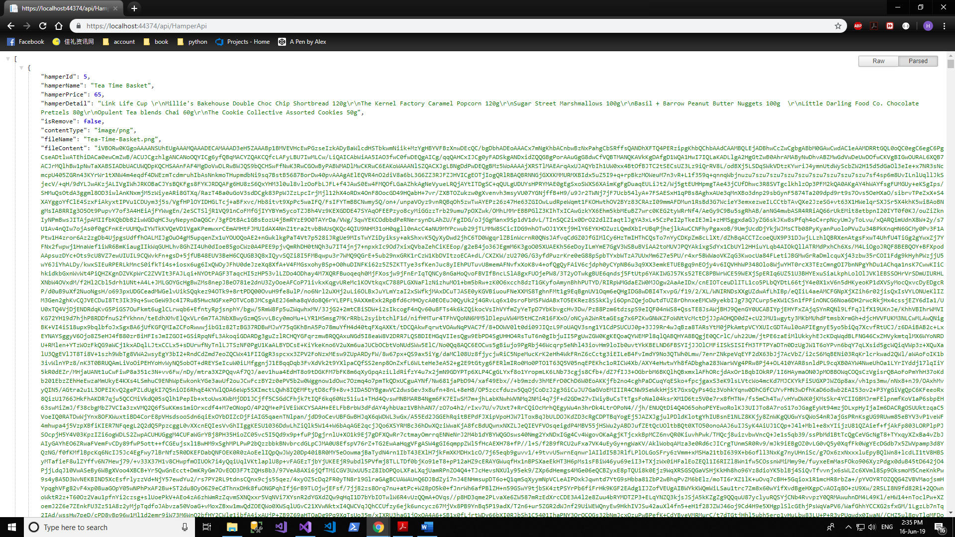



## Get Data by Category



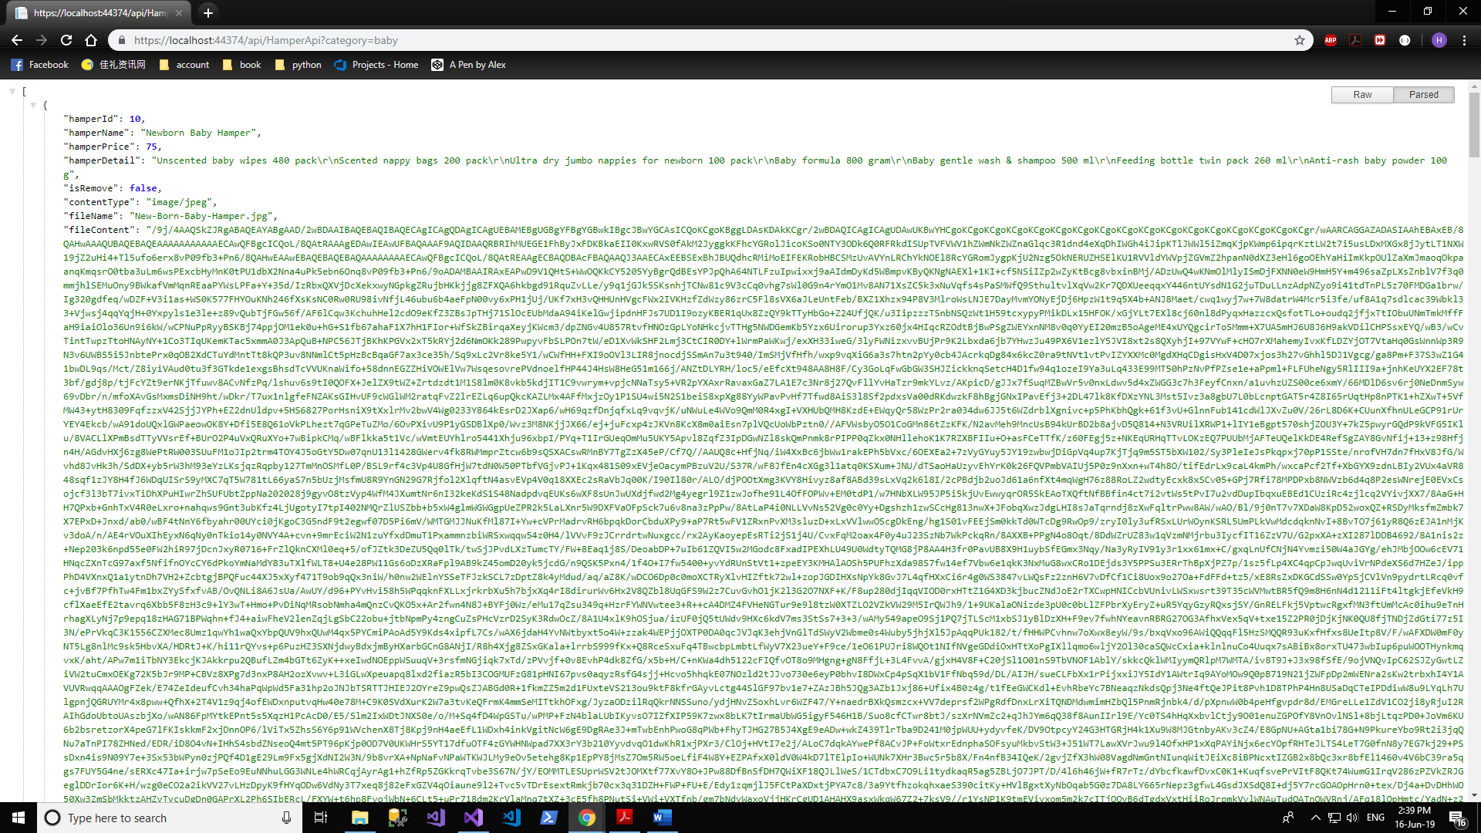

# **Source Code Control on Microsoft Devops**

## Version Control

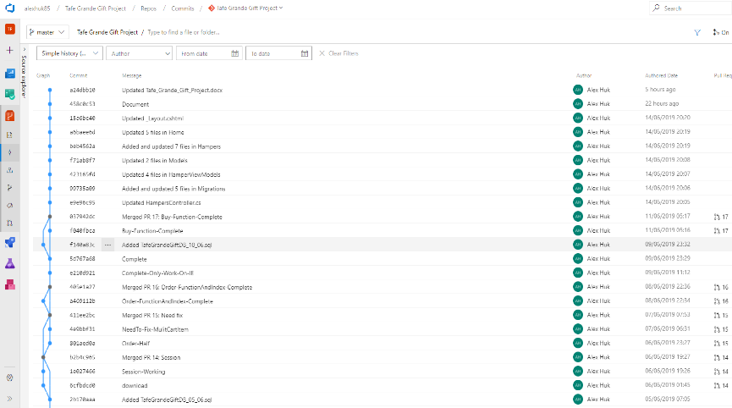

## User Story Board

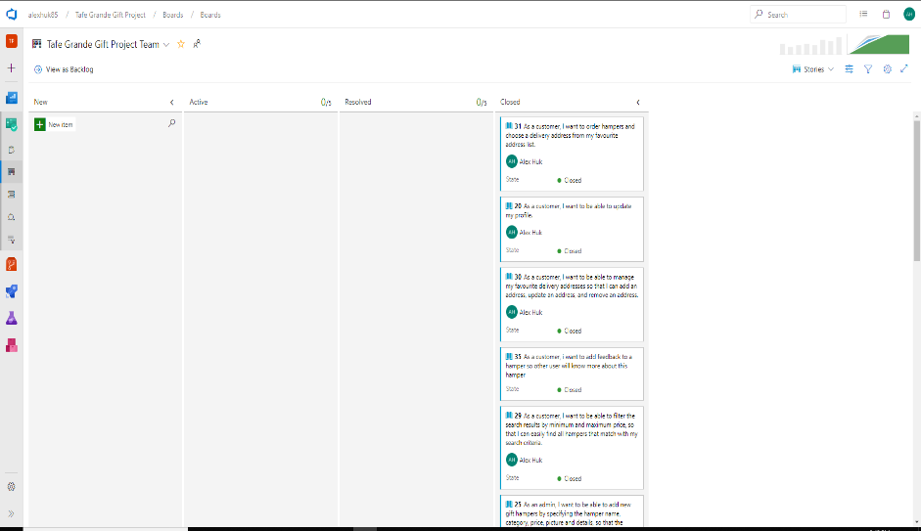

## Work Flow Chart

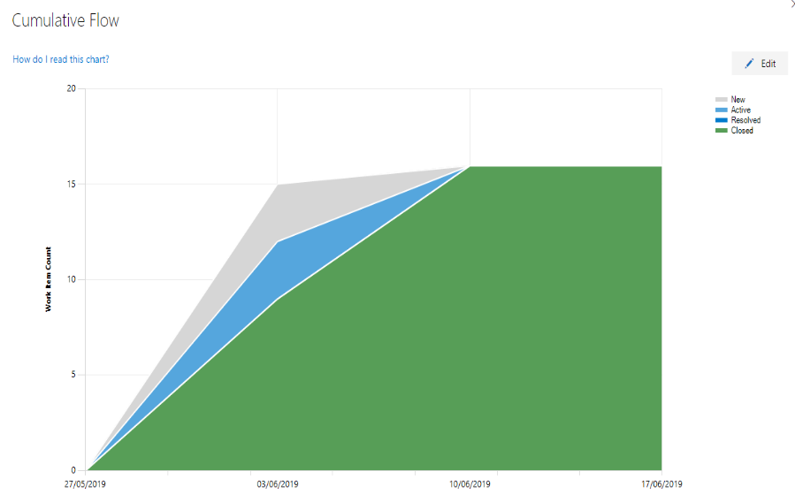

# **Deploy on Microsoft Azure**

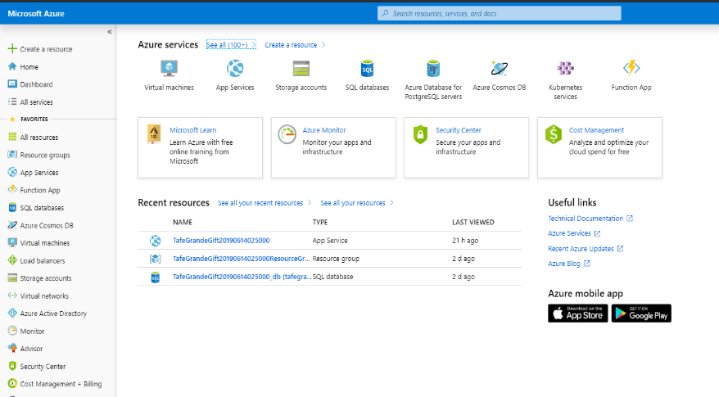

## Web App URL

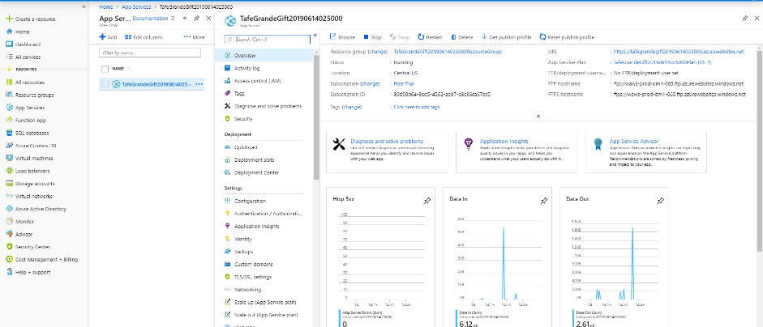

## Database

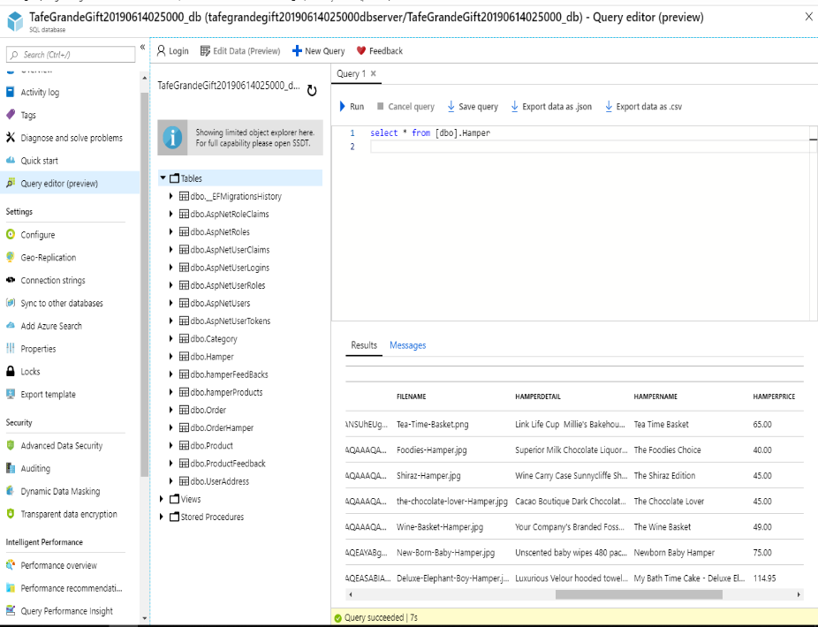

## Web Page

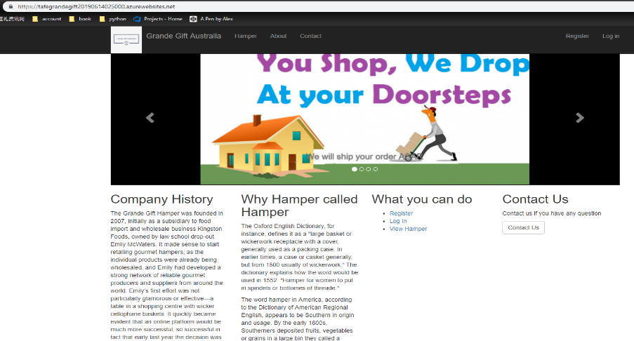



# **To Find Out More…**

Microsoft Devops - <https://dev.azure.com/alexhuk85/Tafe%20Grande%20Gift%20Project>

Online Web App - <https://tafegrandegift20190614025000.azurewebsites.net/>